Apple Pie
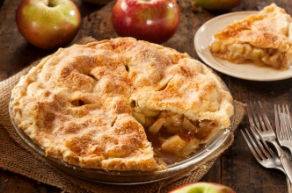
Apple choices can vary depending on taste and preference. Some cooks swear by cooking and baking apples, others just use what’s available or on sale.
Prep: 30 Mins / Bake: 1 hour / Oven: 375 F / Serves: 6-8

Filling Ingredients
- 6-8 Cups of Apples cored, peeled, thinly sliced or chunked (around 6 large to 8 med/small apples, about 2 ¼ pounds)
- 2 Tablespoons lemon juice [more or less]
- 1/4 cup brown sugar [more or less] or 2/3 cup granulated sugar [more or less]
- 1/4 cup all-purpose flour [more or less, start by adding 2 Tablespoons at a time]
- 1 teaspoon cinnamon
- 1/4 teaspoon nutmeg
- 1/8 teaspoon cloves (optional)
- 1/4 teaspoon ginger (optional)

- 2 Tablespoons butter
- Splash of milk
- Sprinkling of sugar

Directions
- Preheat oven to 375 degrees F.

- Gather ingredients. Begin peeling, coring, and slicing the apples into chunks or thin slices and place in a bowl. The lemon juice will help keep the apples from turning brown. Add the sugar, flour and spices. Stir together. More sugar or flour or spices may be added to taste.

- Prepare your double pie pastry by rolling it out according to the directions.

- Transfer apple mixture to the pastry-lined pie plate. Trim the bottom pastry to just overlap the edge of the pie plate.

- Take the remaining 2 Tablespoons of butter and cut into ¼ inch pats and place on top of apple mixture.

- Cover the entire pie with remaining rolled out dough. Pierce holes in the top of dough to allow heat to escape (so there isn’t a steam buildup inside the pie).

- Seal the edges of the pie by fluting the dough (stamping the dough with a fork or your fingers) around the edge of the pie pan.

- Brush the top of the pastry with milk and sprinkle with additional sugar. To prevent over-browning, cover the edge of the pie with foil.

- Bake at 375 F for 40 mins. Remove the foil and bake another 20 minutes more until the fruit is tender and the filling is bubbly. Cool on a wire rack.

