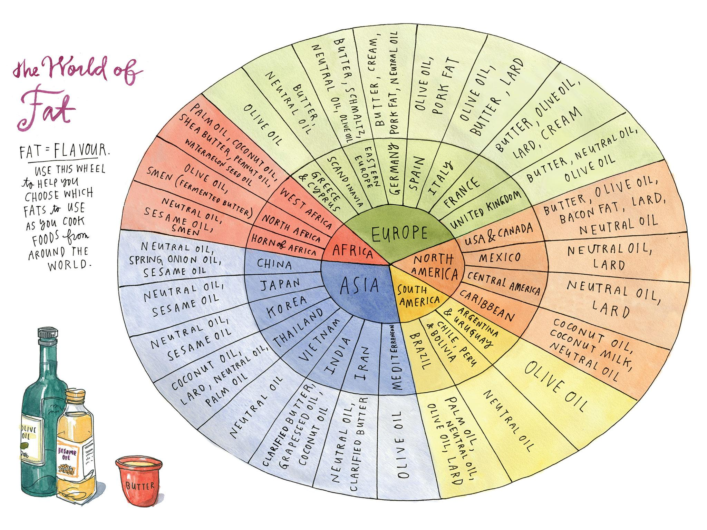
Fats and oils are not just a caloric powerhouse but they also serve many chemical, physical, and nutritional functions in the foods we eat. Here are ten of the most important functions that fats serve in food.​

1. Appearance
Fats and oils can alter a food’s appearance by creating a glossy or moist visual texture. The ability of fat to refract light is also responsible for the opaque appearance of milk. Fats also aid in the browning process of many foods, giving them an appealing golden brown color.​

2. Emulsions
Fats and oils are an important component in most emulsions. Emulsions are the dispersion of a fat or oil into water (or vice versa). There are many emulsions in the culinary world including salad dressings, mayonnaise, gravies, and cheese sauces. Emulsifying fat into a liquid produces unique flavor and texture qualities.

3. Flavor
Fat has the unique ability to absorb and preserve flavors. Oils are often infused with herbs and spices for preservation. Fats also contain compounds that lend specific flavors of their own. The way fat coats the tongue and allows flavors to linger can also alter a flavor experience.

4. Heat Transfer
Fats provide one of the most efficient modes of heat transfer during cooking. From deep fat frying to sautéing in a skillet or wok, hot oil is able to transfer high levels of heat to the surface of food without overheating the interior portions. Using fats and oils to transfer heat also facilitates crust formation

5. Melting Point
The type of fat used in a product often determines the melting point of the final product. A melting point is the temperature at which a substance changes from a solid to a liquid. This characteristic is especially important for items like chocolate, frosting, and salad dressings. Saturated fats, like butter and lard, are solid and room temperature, which make them perfect for using solid foods like chocolate and frosting. Vegetable oils are liquid at room temperature, which makes them perfect for use in products like salad dressings. The low melting point of vegetable oils allows salad dressings to stay in liquid form when refrigerated.

6. Nutrition
Fats are the most calorie dense compound in food, weighing in at over twice the calories per gram of proteins or carbohydrates. While this may not be seen as an advantage in today’s modern society, the ability to provide energy dense food items is still necessary in many parts of the world. Fat is an effective method of delivering calories when needed. Fats are also important for delivering fat-soluble vitamins such as Vitamins A, E, D, and K.

7. Satiety
Fats play an important role in making foods satisfying or making us feel full. Because fats take longer to digest than carbohydrates or proteins, high-fat foods stay in the stomach longer and delay the feeling of hunger.

8. Shortening
Shortening is not just the name of a solid, shelf stable fat but it is also the term used to describe fat’s ability to make baked goods tender by impeding the formation of gluten strands. Normally, as bread dough is kneaded the gluten (wheat protein) begins to join and form long elastic strands, which give strength and a chewy texture to the bread. When fat is added to dough, like in biscuits and pie crusts, the fat gets in the way of the gluten formation, therefore keeping the final product tender and flakey.

9. Solubility
While fats and oils are not soluble in water, there are other chemical compounds that are only soluble in fats. Many of these fat-soluble compounds are responsible for foods flavor and even vitamin content. Including fat in food allows for maximum flavor and a wider range of nutritional content.

10. Texture
Fats and oils have a texture all their own but are also responsible for tenderizing baked goods via the shortening process (see above). Fat provides a very specific, lubricating mouthfeel, which is why most dry crackers or chips are served with high fat content dips or spreads. Emulsions made with fat are responsible for the creamy texture of many items like ice cream, mayonnaise, and other sauces.

