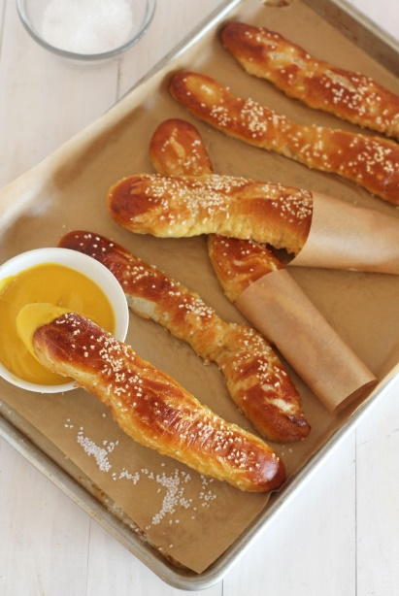
German Soft Pretzel Sticks

Cook time 10 mins Total time 97 mins or 1hr 40 mins

Author: Melanie - Gather for Bread
Recipe type: Pretzel
Cuisine: Appetizer or Snack
Serves: 24
Ingredients
- ½ cup light brown sugar
- 2 cups warm water (about 110 degrees)
- 5½ teaspoons active dry yeast
- ¼ cup vegetable or canola oil or olive oil
- 5¾ cups all-purpose flour, plus more for kneading
- ¾ cup baking soda

- 1 large egg beaten with 1 tablespoon of water (egg wash)
- 1 Tablespoon of butter (for buttering parchment or Silpat baking mats)
- Coarse salt for sprinkling

Instructions
- In the large bowl of a stand mixer, combine the brown sugar and 2 cups of warm water until dissolved. Sprinkle the yeast over the water and let stand until foamy, about 5 minutes. Attach the kneading arm and stir in the vegetable oil and 3 cups of the flour. Knead in the remaining 2¾ cups of flour; the dough will be slightly sticky. Knead until smooth and silky, about 3 minutes. If the dough is very sticky, knead in up to ¼ cup more flour.

- Transfer the dough to a large, greased bowl, cover with plastic wrap and let stand at room temperature until doubled, about 45 minutes.

- Preheat the oven to 450°.

- Line 3 large baking sheets with parchment paper and butter the paper or use Silpat baking mats. Punch down the dough and turn it out onto a floured surface. Knead the dough lightly until smooth and non-sticky. Add 1 tsp more flour at a time if too sticky. Roll it into a loaf and cut it into 24 equal pieces. Roll each piece into a 7-8 inch stick about ½ inch thick. Transfer the sticks to the prepared baking sheets, leaving at least 2 inches between them. Let stand uncovered until puffed, about 5 to 25 minutes.

- While the pretzels are resting. In a large, deep skillet or pot, stir the baking soda into 2 quarts of water and bring to a simmer over high heat. You may need to add additional hot water as needed. Reduce the heat to medium. Using 2 slotted spoons or a pair of tongs, carefully transfer 6 to 8 pretzel sticks at a time to the simmering water for a total of 30 seconds. Turning once after 15 seconds. Add about 1 cup of hot water if needed before cooking the second batch of pretzels. Transfer the pretzel sticks to paper towels to drain, then return them to the baking sheets, spacing them evenly. Add another cup of hot water before each batch if needed.

- Brush the pretzel sticks with the egg wash and sprinkle with coarse salt. Bake until deeply browned, about 10 minutes. Serve warm or at room temperature.

