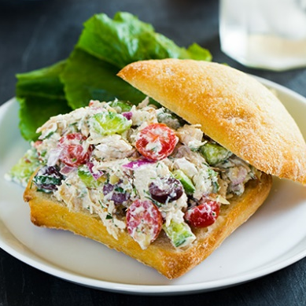
Greek Chicken Salad Sandwiches

Ingredients
- 1 lb boneless skinless chicken breasts, cooked, chilled to cool and diced*
- 1 cup diced mini Persian cucumbers
- 3/4 cup sliced grape tomatoes (I sliced each into 3 slices)
- 1/2 cup feta cheese, crumbled
- 1/3 cup chopped red onion
- 1/4 cup diced Kalamata olives
- 3 Tbsp sliced almonds (optional)
Dressing
- 1/2 cup non-fat or low-fat plain greek yogurt
- 1/4 cup sour cream
- 1 clove garlic, minced
- 1 Tbsp chopped fresh dill (or 1 tsp dried)
- 1 Tbsp chopped fresh parsley (or 1 tsp dried)
- 1 Tbsp lemon juice, preferably fresh
- Salt and freshly ground black pepper, to taste
Directions
- To a mixing bowl add, diced chicken, cucumbers, tomatoes, feta cheese, red onion, Kalamata olives and sliced almonds. Add dressing and toss to evenly coat. Serve over bread, rolls, croissants, wraps, or in pita pockets. For best results serve within 3 hours of preparing (for best crunchiness of cucumbers and almonds), store in refrigerator.
- For the dressing: In a mixing bowl, whisk all of the dressing ingredients together to blend and season with salt and pepper to taste.

Notes: To cook the chicken I placed the raw chicken in the slow cooker, added 2 cups low-sodium chicken broth and a bit of salt and fresh ground black pepper then covered with lid and cooked on low heat until cooked through (4 - 6 hours depending on the size of the chicken breasts). Or you could use a can of cooked chicken breast.

http://www.cookingclassy.com/2013/10/greek-chicken-salad-sandwiches/

