YIELD: 4 SERVINGS

Vegan Mushroom Wild Rice Soup
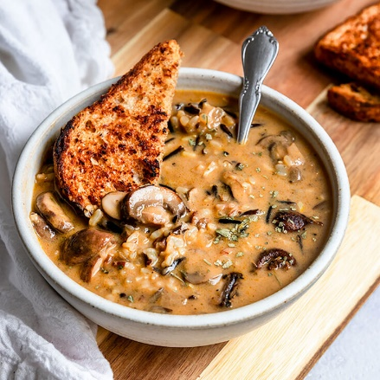
A creamy & dairy-free soup with wild rice, meaty mushrooms, onions, and a truly flavorful soup broth. The most comforting vegan & gluten-free soup!
PREP TIME5 minutes
COOK TIME55 minutes
TOTAL TIME1 hour

Ingredients
- 3/4 cup wild rice blend
- 4 cups mushrooms, diced (I used a mix of white button, Crimini, & Shitake)
- 1 cup white onion, diced
- 2 cloves minced garlic (about 1 Tbsp)
- 2 Tbsp vegan butter (or oil)
- 1 tsp dried parsley
- 5-6 cups vegetable broth (I start with 5 and add up to 6 for a slightly thinner soup)
- 14 oz can coconut milk
- salt & pepper to taste

Instructions
- First, rinse the wild rice and add it to a small or bowl to soak in cold water for 15-30 minutes.
- While the rice is soaking, chop & prep the vegetables. Slice the mushrooms thinly (removing the bottom of the stems if desired) and finely dice the onions.
- Next, add the vegan butter to a large soup pot and turn on the heat. Once the butter has melted, add in the onion, garlic, and mushrooms. Then, sauté for 15 minutes until the onions & mushrooms are beginning to crisp up and brown. Make sure to stir consistently to evenly cook the vegetables.
- Once the vegetables are cooked, season with a mix of parsley, salt, and pepper. Then, add the vegetable broth, soaked & strained wild rice, and coconut milk to the pot with the vegetables. Stir to mix together.
- Bring the pot of soup to a boil. Then, reduce the heat to a simmer and cook covered for 20 minutes.
- At the 20-minute mark remove the soup lid, stir the soup, and cook the soup uncovered for an additional 15-20 minutes until the rice is cooked through. (Please note, if you are using a rice other than wild rice, cooking time will vary, so check if it is done at the 20-minute mark).
- Remove the soup from the heat and let it sit for 5 minutes to thicken. Finally, serve and enjoy!

Notes
- Soup can be stored as leftovers in a closed container in the fridge. Any leftovers will thicken substantially as the rice will absorb the liquid, so add in extra vegetable broth for a soup-like consistency when eating leftovers.
- To get the rich color you see pictured, it's crucial to use a high-quality thick veggie broth/stock. I used Pacific Foods Brand.

Nutrition Information:

YIELD:
4

SERVING SIZE:
1 bowl
Amount Per Serving: CALORIES: 457TOTAL FAT: 29gSATURATED FAT: 23gTRANS FAT: 0gUNSATURATED FAT: 3gCHOLESTEROL: 15mgCARBOHYDRATES: 43gFIBER: 5gSUGAR: 16gPROTEIN: 11g
ShortGirlTallOrder occasionally offers nutritional information for recipes contained on this site. This information is provided as a courtesy and is an estimate only. This information comes from online calculators. Although shortgirltallorder.com attempts to provide accurate nutritional information, these figures are only estimates.
Full Recipe can be found at:
https://shortgirltallorder.com/vegan-mushroom-wild-rice-soup?utm_medium=social&utm_source=pinterest&utm_campaign=tailwind_tribes&utm_content=tribes&utm_term=1007181932_45927590_508940
© Megan Horowitch

