MY OTHER RECIPES

PAN FRIED DUMPLINGS
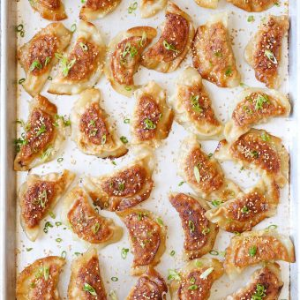
YIELD: 40 DUMPLINGS

PREP TIME: 25 MINUTES

COOK TIME: 15 MINUTES
TOTAL TIME: 40 MINUTES
The best and easiest way to cook amazingly crisp potstickers! After this, you’ll never want take-out dumplings ever again. Promise!

INGREDIENTS:
- 1 pound ground pork
- 1 zucchini, shredded
- 1 carrot, peeled and shredded
- 1 cup shredded Napa cabbage
- 2 large eggs, lightly beaten
- 2 cloves garlic, minced
- 2 green onions, thinly sliced
- 3 tablespoons reduced sodium soy sauce
- 1 tablespoon sesame oil
- 1 tablespoon freshly grated ginger
- 1 tablespoon mirin
- 1 teaspoon sugar
- Kosher salt and freshly ground black pepper, to taste
- 40 won ton wrappers
- 2 tablespoons vegetable oil, or more, as needed

DIRECTIONS:
- In a large bowl, combine pork, zucchini, carrot, cabbage, eggs, garlic, green onions, soy sauce, sesame oil, ginger, mirin and sugar; season with salt and pepper, to taste.*
- To assemble the dumplings, place wrappers on a work surface. Spoon 1 tablespoon of the pork mixture into the center of each wrapper. Using your finger, rub the edges of the wrappers with water. Fold the dough over the filling to create a half-moon shape, pinching the edges to seal.*
- Heat vegetable oil in a large skillet over medium heat. Working in batches, add dumplings in a single layer and cook until bottoms begin to brown, about 30 seconds. Add 1/2 cup water, cover and cook for 3 minutes; uncover and cook until the liquid has evaporated completely and the bottoms are crisp and golden brown, about 2 more minutes. Repeat with remaining dumplings, adding more vegetable oil as needed.
- Serve immediately.
*The filling in the dumplings does not have to be cooked prior to wrapping.
*To freeze, place uncooked dumplings in a single layer on a baking sheet overnight. Transfer to freezer bags.

This delicious recipe brought to you by DAMN DELICIOUS
https://damndelicious.net/2016/01/15/pan-fried-dumplings/

