MY OTHER RECIPES

POTSTICKERS
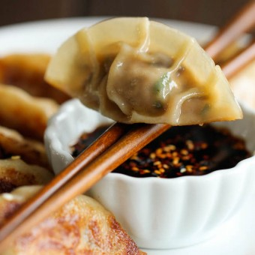
YIELD: 6 SERVINGS

PREP TIME: 20 MINUTES

COOK TIME: 10 MINUTES
TOTAL TIME: 30 MINUTES
Homemade potstickers are easier to make than you think, and they taste 10000x better than the store-bought ones!

INGREDIENTS:
- 1 pound ground pork
- 1 cup shredded green cabbage
- 3 ounces shiitake mushrooms, diced
- 2 cloves garlic, pressed
- 2 green onions, thinly sliced
- 1 tablespoon hoisin
- 1 tablespoon freshly grated ginger
- 2 teaspoons sesame oil
- 1 teaspoon Sriracha*, or more, to taste
- 1/4 teaspoon white pepper
- 36 won ton wrappers
- 2 tablespoons vegetable oil Soy sauce, for serving

DIRECTIONS:
- In a large bowl, combine pork, cabbage, mushrooms, garlic, green onions, hoisin, ginger, sesame oil, Sriracha and white pepper.
- To assemble the dumplings, place wrappers on a work surface. Spoon 1 tablespoon of the pork mixture into the center of each wrapper. Using your finger, rub the edges of the wrappers with water. Fold the dough over the filling to create a half-moon shape, pinching the edges to seal.
- Heat vegetable oil in a large skillet over medium heat. Add potstickers in a single layer and cook until golden and crisp, about 2-3 minutes per side.
- Serve immediately with soy sauce, if desired.
*Sriracha is an Asian-style hot chili sauce and can be found in the Asian section of your local grocery store.
To freeze, place uncooked potstickers in a single layer on a baking sheet overnight. Transfer to freezer bags.

This delicious recipe brought to you by DAMN DELICIOUS
https://damndelicious.net/2014/03/01/potstickers/

