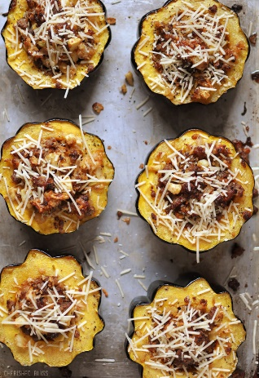
Prep time
Substitutions/Additions/Considerations

Dried Fruit Chopped Nuts
Dried cranberries Pecans
Dried cherries Walnuts
Raisins Chestnuts
Dried Dates Almonds

Meat and Alternatives
Pork Sausage Black Beans
Ground Beef Potatoes
Ground Turkey Tofu
Diced poultry (chx, txy)
Vegetarian Sausage

Vegetables/Fruits
Mushrooms Cauliflower
Carrots Pears
Corn Spinach

Cheeses
Cheddar Parmesan
Feta Goat Cheese
15 mins
Cook time
1 hour
Total time
1 hour 15 mins

Author: Ashley
Ingredients
- 3 Acorn Squash, halved
- Olive Oil
- Salt & Pepper
- 1 lb. Ground Sausage
- 1 Small Onion, finely chopped
- 2 Large Celery Stalks, finely chopped
- 2 Apples, diced
- ½ tsp sage
- 1 cup Panko Bread Crumbs
- 1 cup Parmesan Cheese, divided
Instructions
- Preheat oven to 400 degrees.
- Using a sharp knife cut off each end of the acorn squash removing as little as possible, then cut in half.
- Spoon out seeds.
- Brush olive oil inside and on top of Acorn Squash.
- Sprinkle Salt and Pepper over Acorn Squash to taste.
- Bake for 40 minutes to an hour depending on size of your squash until tender and you can pierce with a fork, but still holding its shape.
- While the squash is baking begin sautéing the sausage for about 5 minutes, drain and pat dry with a paper towel to remove as much grease as possible, but don't discard grease in the pan.
- Using the grease from the sausage add your onions and celery to the pan and sauté for another 2-3 minutes until it starts to brown. (add olive oil if necessary)
- Add apples and sauté for another 2 minutes or until softened.
- Stir in sage and bread crumbs.
- Add ¾ cup parmesan cheese and stir until cheese begins to melt. Set aside.
- Once squash has finished baking and reached desired tenderness spoon in meat mixture until the squash is filled.
- Return to the oven and bake an additional 15-20 minutes depending on size of squash.
- Remove from oven and top with remaining parmesan cheese.
- Enjoy!

