Yeast's Crucial Roles in Breadbaking

It acts as a leavener, dough developer, and flavor builder

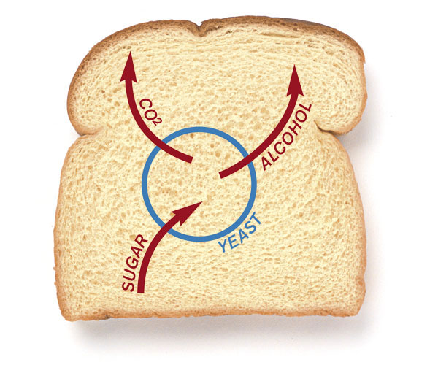
By Shirley Corriher Fine Cooking Issue 43

Yeast is the driving force behind fermentation, the magical process that allows a dense mass of dough to become a well-risen loaf of bread. And yet yeast is nothing more than a single-celled fungus. How does it do it?
Yeast works by consuming sugar and excreting carbon dioxide and alcohol as byproducts. In bread making, yeast has three major roles. Most of us are familiar with yeast’s leavening ability. But you may not be aware that fermentation helps to strengthen and develop gluten in dough and also contributes to incredible flavors in bread.

Yeast makes dough rise
The essentials of any bread dough are flour, water, and of course yeast. As soon as these ingredients are stirred together, enzymes in the yeast and the flour cause large starch molecules to break down into simple sugars. The yeast metabolizes these simple sugars and exudes a liquid that releases carbon dioxide and ethyl alcohol into existing air bubbles in the dough.
If the dough has a strong and elastic gluten network, the carbon dioxide is held within the bubble and will begin to inflate it, just like someone blowing up bubblegum. As more and more tiny air cells fill with carbon dioxide, the dough rises and we’re on the way to leavened bread.
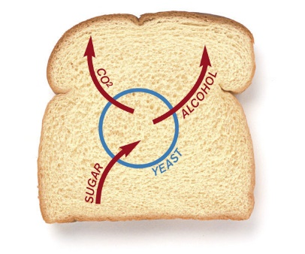
Yeast cells thrive on simple sugars. As the sugars are metabolized, carbon dioxide and alcohol are released into the bread dough, making it rise.

Yeast strengthens bread dough
When you stir together flour and water, two proteins in the flour—glutenin and gliadin—grab water and each other to form a bubblegum-like, elastic mass of molecules that we call gluten. In bread making, we want to develop as much gluten as we can because it strengthens the dough and holds in gases that will make the bread rise.
Once flour and water are mixed together, any further working of the dough encourages more gluten to form. Manipulating the dough in any way allows more proteins and water to find each other and link together. If you’ve ever made homemade pasta, you know that each time you roll the dough through the machine, the dough becomes more elastic; in other words, more gluten is developed. And with puff pastry dough, every time you fold, turn, and roll the dough, it becomes more elastic.
Yeast, like kneading, helps develop the gluten network. With every burst of carbon dioxide that the yeast releases into an air bubble, protein and water molecules move about and have another chance to connect and form more gluten. In this way, a dough’s rising is an almost molecule-by-molecule kneading. Next time you punch down bread dough after its first rise, notice how smooth and strong the gluten has become, in part from the rise.
At this stage, most bakers stretch and tuck the dough into a round to give it a smooth, tight top that will trap the gases produced by fermentation. Then they let this very springy dough stand for 10 to 15 minutes. This lets the gluten bonds relax a little and makes the final shaping of the dough easier. This rounding and resting step isn’t included in many home baking recipes, but it’s a good thing to do.

Fermentation generates flavor in bread
As Harold McGee, the author of On Food & Cooking, has pointed out, big molecules in proteins, starches, and fats don’t have much flavor, but when they break down into their building blocks—proteins into amino acids, starches into sugars, or fats into free fatty acids—they all have marvelous flavors. Fermentation, whether it’s acting on fruit juices to make wine or on flour to make bread, does exactly that—it breaks down large molecules into smaller, flavorful ones.
At the beginning of fermentation, enzymes in the yeast start breaking down starch into more flavorful sugars. The yeast uses these sugars, as well as sugars already present in the dough, and produces not only carbon dioxide and alcohol but also a host of flavorful byproducts such as organic acids and amino acids. A multitude of enzymes encourages all kinds of reactions that break big chains of molecules into smaller ones—amylose and maltose into glucose, proteins into amino acids.
As fermentation proceeds, the dough becomes more acidic. This is due in part to rising levels of carbon dioxide, but there are also more flavorful organic acids like acetic acid (vinegar) and lactic acid being formed from the alcohol in the dough. (This is similar to what happens to a bottle of wine that has been left uncorked for a while: the alcohol combines with oxygen to make vinegar.) The acidity of the dough causes more molecules to break down. The dough becomes a veritable ferment of reactions. Eventually, the amount of alcohol formed starts to inhibit the yeast’s activity.
Yeast has help in producing flavorful compounds. Bacteria are important flavor builders as well. There are bacteria in the dough from the beginning, but as long as the yeast is very active, it consumes sugars as quickly as they’re produced, leaving no food for the bacteria, which also like sugar. But when bakers chill a dough and slow down its rise, the cold dramatically reduces yeast activity. The bacteria, on the other hand, function well even in cold temperatures, so they now have an opportunity to thrive, producing many more marvelously flavorful acids.

